**Overview Of the Project**

This report provides insights derived from the analysis of the Performance used cars market at DriveWave Motors in India from 1998 to 2020. It highlights key trends, customer preferences, and actionable recommendations to drive strategic decision-making.

Methodology:

The dataset was gotten from Kaggle and excel was used for cleaning while powerbi was used for visualization

**Key Insights**

1. **Sales Trend Analysis**:
   * Used car prices showed significant growth between 2005 and 2016, peaking in 2016.

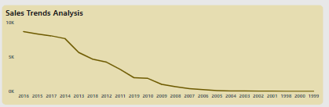

**Further Investigation**:

* Analyze economic or regulatory events post-2016 that might have influenced the used car market.
* Study customer purchase behavior to identify reasons for the decline in demand.

1. **Sales by Car Transmission**:
   * Manual transmission vehicles dominate the market, with 72.27% of sales.
   * Automatic cars represent 27.73%, showing slower adoption, though urban areas might reflect a growing trend.

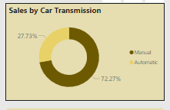

**Further Investigation**:

* Conduct a city-wise analysis to determine where automatic transmission demand is higher.
* Study if younger or first-time car buyers prefer automatic cars to predict future shifts in demand.

1. Top Performing Cars:

The Mahindra XUV500 W8 2WD is the best-performing car, followed by the Toyota Fortuner 3.0 Diesel. These two models have generated revenue of 19M and 12M, respectively.

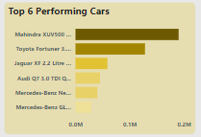

Further Investigation:

Evaluate why other models are not getting sold and accepted by buyers

1. **Fuel Type Preferences**:
   * Diesel cars lead the market with 52.68%, followed by Petrol vehicles at 46.34%.
   * Alternative fuel options (CNG, LPG, Electric) have minimal market penetration, reflecting untapped potential.

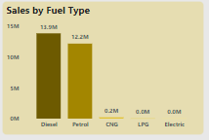

**Further Investigation**:

* Evaluate government policies promoting electric vehicles (subsidies, tax breaks) and their potential market impact.
* Study fuel price trends and their correlation with the shift in consumer preferences.

1. **Analysis of car type Across the City**:
   * The Mahindra XUV500 and Toyota Fortuner 3.0 Diesel are the most popular and widely used car models across Indian cities.

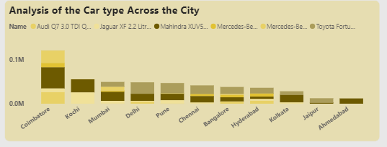

**Further Investigation**:

* Analyze reason why other models were not been used or well bought in other cities and how the market of them can get better

1. **Geographical Analysis**:
   * High sales concentrations in cities such as Combitore, Mumbai, Kochi, Hyderabad, Bangalore, and Delhi reflect regional economic strength and purchasing power.
   * These cities represent key growth opportunities.

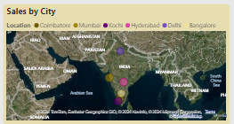

**Further Investigation**:

* Conduct a deep dive into demographic and economic factors in these cities to identify why they perform better.
* Explore underperforming regions and analyze barriers to entry (e.g., lack of dealerships, lower income levels).

1. **Sales by Ownership Type**:
   * First-owner cars dominate the market (22M sales), reflecting consumer preference for less-used vehicles.
   * Second-owner vehicles account for only 4M sales, suggesting potential for improvement in trust and affordability.

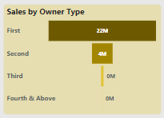

**Further Investigation**:

* Study customer perception of second-owner cars and barriers to purchase.
* Assess resale values of first-owner cars across brands/models to improve pricing strategies.

**Recommendations for Strategic Decision-Making**

1. **Reviving Sales Growth**:
   * Investigate the factors behind the sales decline after 2016, such as economic shifts or regulatory changes.
   * Revitalize demand through targeted marketing strategies, including discounts, trade-in programs, and flexible financing options.
2. **Fuel-Type Focus**:
   * Maintain a robust inventory of petrol and diesel vehicles to meet current consumer demand.
   * Invest in educating customers about alternative fuel options like electric and CNG to prepare for future market trends.
3. **Capitalizing on Manual Transmission Preference**:
   * Prioritize stocking and marketing manual transmission cars to cater to the majority of customers.
   * Gradually increase the availability of automatic cars, particularly in urban markets where demand for convenience is rising.
4. **Geographic Expansion**:
   * Strengthen dealership networks and localized marketing campaigns in high-demand cities like Mumbai, Bangalore, and Hyderabad.
   * Explore untapped regions to identify barriers and implement strategies to boost sales.
5. **Addressing Owner-Type Preferences**:
   * Emphasize first-owner cars in marketing campaigns, focusing on their reliability and condition.
   * Enhance inspection and certification programs to build trust in second-owner vehicles and increase their appeal.
6. **Preparing for Market Evolution**:
   * Gradually introduce eco-friendly options such as electric and hybrid vehicles by collaborating with manufacturers.
   * Monitor government policies for incentives and subsidies that could drive the adoption of alternative fuel vehicles.
7. **Model-Specific Marketing**:
   * Promote high-performing models like the BMW X5 and Maruti Swift Dzire VDI by emphasizing their reliability, performance, and efficiency.

**Conclusion**

This analysis identifies key trends and opportunities within the Indian used car market for DriveWave Motors. By addressing customer preferences, leveraging geographic insights, and preparing for emerging trends, stakeholders can optimize strategies for sustainable growth. Immediate priorities should include reviving post-2016 sales, enhancing manual transmission and fuel-type-specific strategies, and preparing for a gradual shift to eco-friendly vehicles.